Requirements document for IdentityFromScratch Project

Our client would like to manually add individual user accounts to a project created initially using the standard ASP.NET Core Web App (Model-View-Controller) template. The purpose of this web site is to test ASP.NET authentication and authorization features. The web site will feature pages to manage users and roles, and a test page to validate various variations of users, roles, policies and claims. The list of users will be stored in a SQL Lite database integrated with the solution.

The Navigation bar should contain links to the **Users**, **Roles** and **Test** pages and a typical standard login component should be displayed on the upper right side of the navigation bar displaying links to **Register** and **Login** when the current user is not logged in, OR the username for the current user and a **Logout** link when the current user is logged in. ALL authentication will be attached ONLY to the test page, allowing even anonymous users access to the management pages (this is a test application, and even anonymous users can manage this system).

The **Users** page will have the following features:

EVERYONE can see an index listing ALL registered users displaying their UserName, Email address, and Email confirmation status, along with a list of roles and claims associated with each user. Additional links will also be displayed to allow the following actions:

EVERYONE will be able to manage the individual Roles, Claims, and create ‘Instant Claims’ for each user

EVERYONE will be able to Confirm the status of a user’s Email address

EVERYONE will be able to Reset the Password for a user to a predefined value (‘HelloHello1!’)

EVERYONE will be able to instantly delete a user with no confirmation (Remove!)

An additional Link to the Roles page (not part of the navigation bar) will be available after the list of all the users.

The **Roles** page will have the following features:

EVERYONE can see an index listing ALL existing roles displaying the role Name. Additional CRUD links will be provided to allow Editing, Updating, Managing Users, and Deleting for each Role. A single Create link will be provided above the list of all roles

EVERYONE will be able to Create new roles

EVERYONE will be able to Edit, Update, and Delete each existing role

EVERYONE will be able to manage the users associated with each existing role

An additional Link to the Users page (not part of the navigation bar) will be available after the list of all the roles.

Requirements document for IdentityFromScratch Project, continued

The **Test** page will have the following features:

The title will indicate that the test page is used to test various security features of the application

A series of ‘Require’ links will be displayed describing each type of required security feature being tested

Require any authenticated user

Require role super

Require role admin

Require user walters

Require user carol

Require age 18

Require age 21

Require age 55

Require state FL

Require state GA

Clicking on a link will either: Take the user to a ‘Succeeded’ page if the requirement is met

Take the user to a login page if the user is not currently logged in

Take the user to an access denied page if the user is logged in but the requirement is not met

Requirements document for IdentityFromScratch Project, continued

A page to allow for managing the roles associated with each user will have the following features:

The title will indicate that roles are being managed, and will identity the user which is being managed

The sub title will indicate the total number of roles that the user being managed belongs to

A list containing ALL roles currently registered in the system will display three columns:

Role Name The name of the role

Member In this Role: Remove (only displayed if the user is in the role)

Not a Member Not in this Role: Add (only displayed if the user is not in the role)

After the list of all roles, the following two links will be available

An additional Link back to the Users page (not part of the navigation bar)  
An additional Link back to the Roles page (not part of the navigation bar)

Clicking on the Remove or the Add links for any role will add or remove the user from that role instantly and will then redisplay the role management page reflecting the requested change

A page to allow for managing the user associated with each role will have the following features:

The title will indicate that users are being managed, and will identity the role which is being managed

The sub title will indicate the total number of users that belong to the role being managed

A list containing ALL users currently registered in the system will display three columns:

User Name The name of the user

Member In this Role: Remove (only displayed if the user is in the role)

Not a Member Not in this Role: Add (only displayed if the user is not in the role)

After the list of all users, the following two links will be available

An additional Link back to the Users page (not part of the navigation bar)  
An additional Link back to the Roles page (not part of the navigation bar)

Clicking on the Remove or the Add links for any role will add or remove the user from that role instantly and will then redisplay the role management page reflecting the requested change

Requirements document for IdentityFromScratch Project, continued

A page to allow for the management of claims associated with each user will have the following features:

The title will indicate that claims are being managed, and will identify the user which is being managed

The sub title will indicate the total number of claims that the user being managed is exposing

A [FORM] section will be displayed allowing for the instant creation of a new claim. The form will display:

(Text input) Type the user will fill this out with the claim name

(Text input) Value the user will fill this out with the claim value

(Submit button) Create Claim Clicking this button will create a new claim and redisplay the same page showing the new claim in the list

A list containing ALL claims currently exposed by the user being managed will display:

Issuer the Issuer data associated with the claim

OriginaIssuer the OriginalIssuer data associated with the claim

Type the claim type: the name of the claim

Value the claim value: the value associated with this claim

Value Type the type of the value (usually a string)

A Link to Removethe claim invokes the remove action, and then redisplays the list

After the list of all claims, the following two links will be available

An additional Link back to the Users page (not part of the navigation bar)  
An additional Link back to the Roles page (not part of the navigation bar)

Clicking on the Remove link for any claim will remove the claim from that user instantly and will then redisplay the claim management page reflecting the requested removal

Sample Users Page

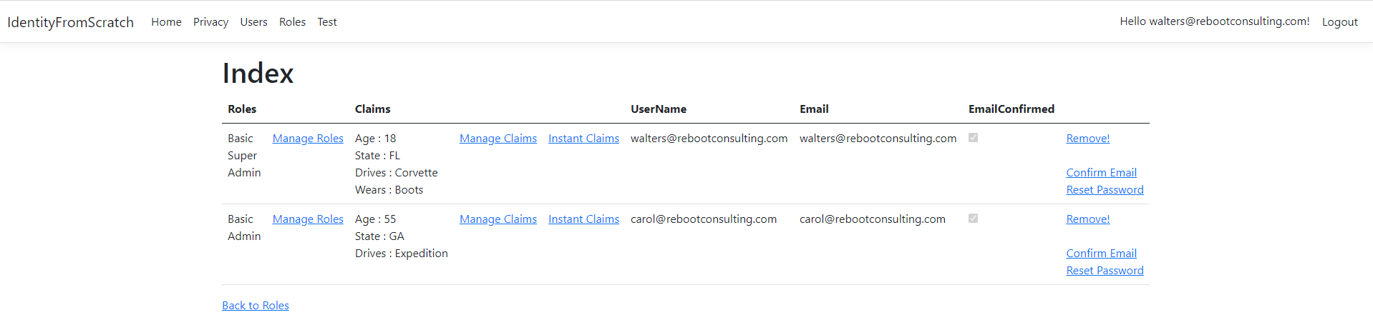

Sample Manage Roles Page

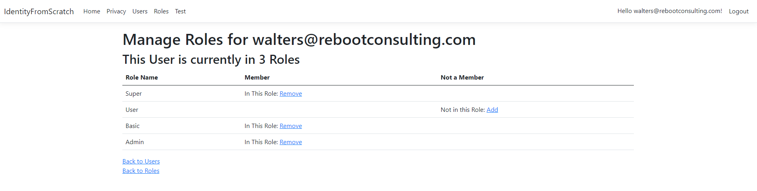

Sample Manage Claims Page

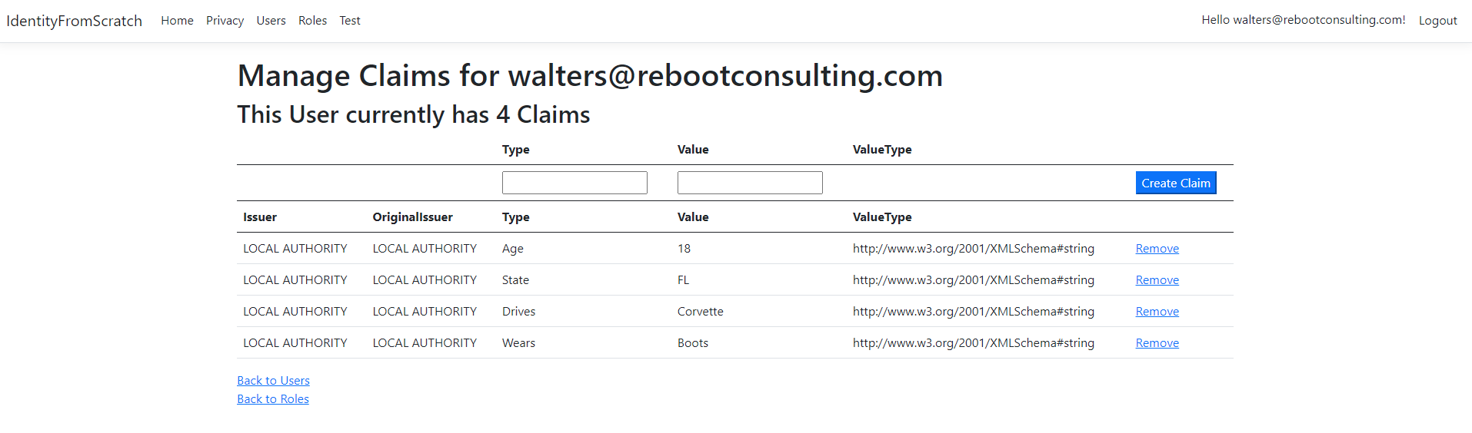

Sample Instant Claims Page

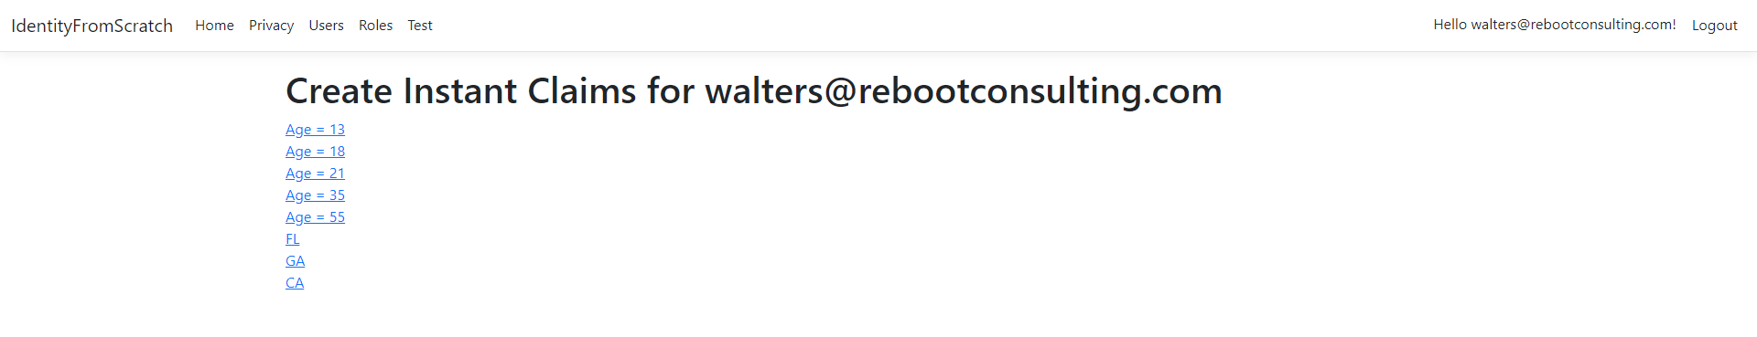

Sample Roles Page

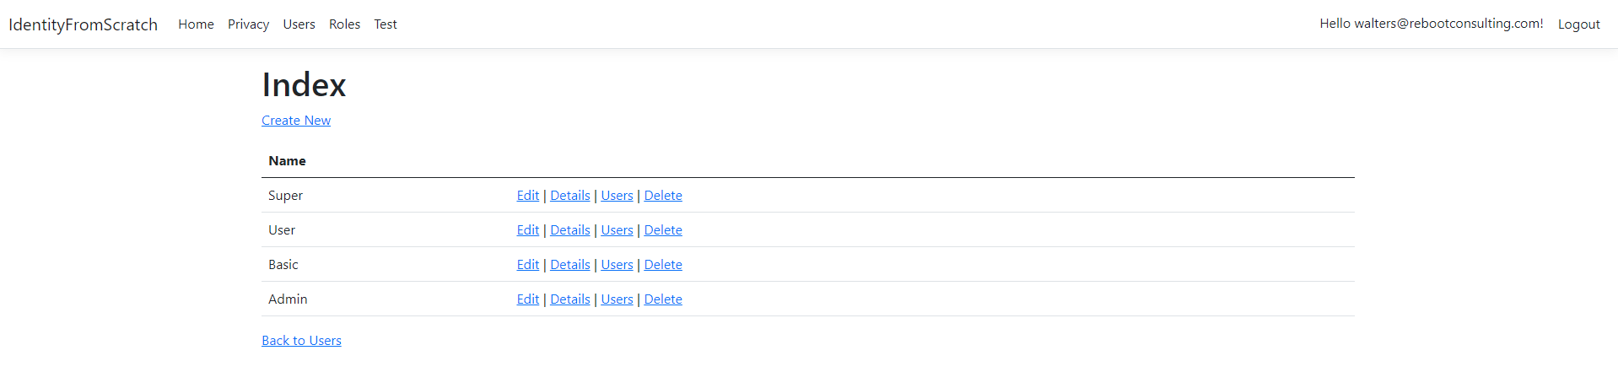

Sample Page for Users off of Roles page : Manage Users

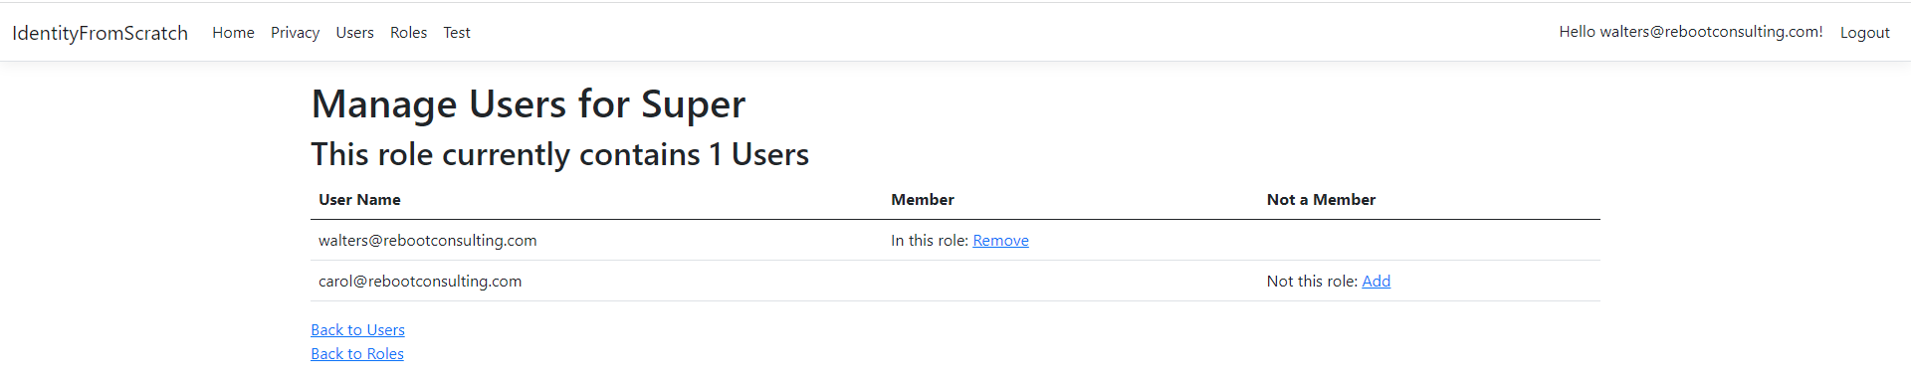

Sample of delete role when no users are in the role

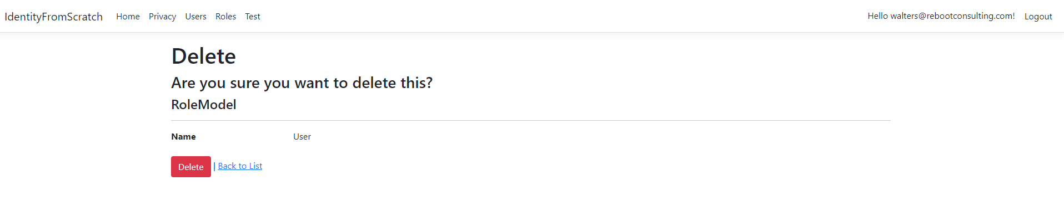

Sample of delete role when the role contains at least one user

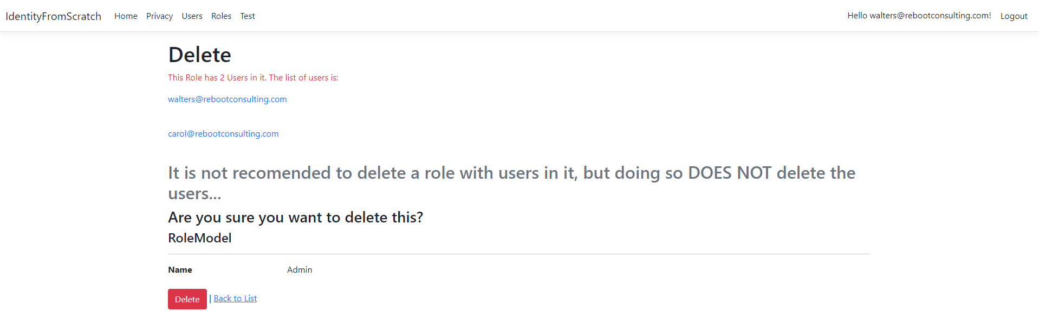

Sample Test page

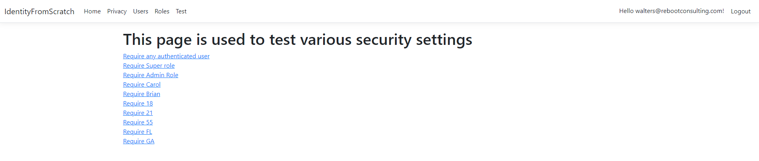

Sample Test page when Access Denied due to Invalid roles (when logged into a user without that role)

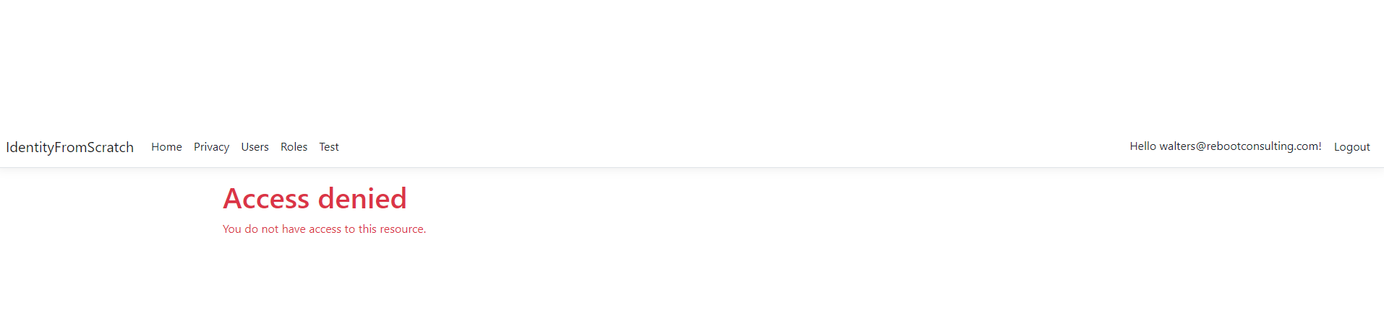

Sample Test page when Access Denied due to Invalid user (when logged into a different user)

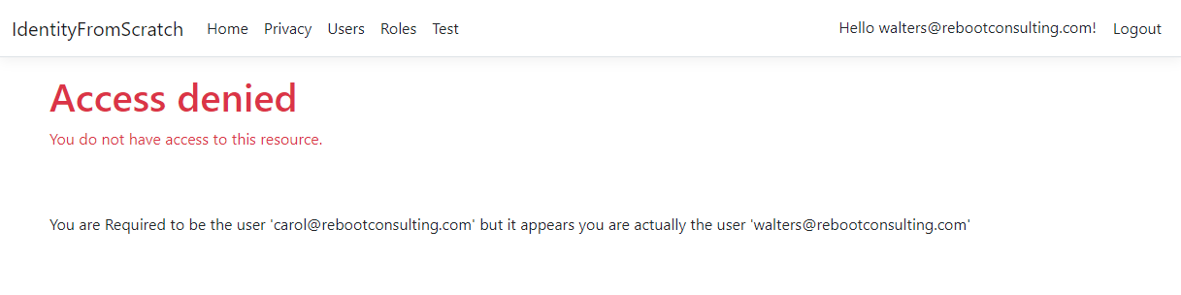

Sample Test page when Access Denied due to age requirement not being met

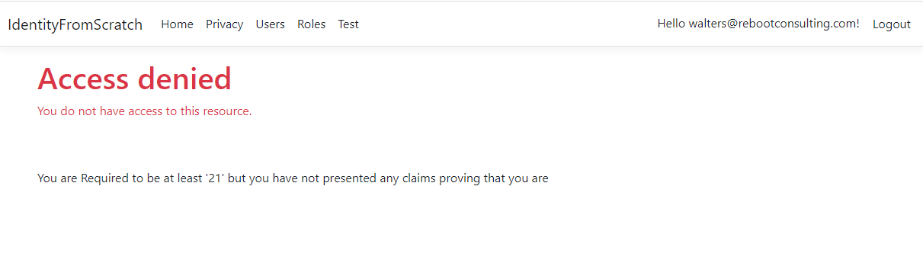

Sample Test page when Access Denied due to state requirement not being met

